Date: 23 June 2008
Division: Mississippi Valley
District: St. Louis

PROJECT FACT SHEET

1. Project. Pools 25 and 26 Islands (PWI 4G7722)

Congressional District: MO-2, MO-9

Authority: Section 1103, Water Resources Development Act of 1986; Authorized purpose - Habitat Rehabilitation and Enhancement (Upper Mississippi River System Environmental Management Program Habitat Rehabilitation and Enhancement Projects)

2. Location. The five islands addressed in this project are located in Upper Mississippi River Pools 25 and 26, and lie about 50 to 100 miles northwest of St. Louis, MO. Howard Island and an adjacent un-named island occur in Pool 25 near Annada, MO at river mile 261. Westport Island is located in Pool 25 near Elsberry, MO between river miles 258 and 254. Dardenne and Bolter Islands are located in Pool 26 near St. Peters, MO at river miles 228 and 224.

3. Description of PROPOSED PROJECT. The proposed project consists of three components to improve terrestrial and aquatic habitats on several islands in Pools 25 and 26 of the Upper Mississippi River: 1) planting of tree and shrub seedlings to reforest portions of abandoned agricultural fields, 2) improving the connection between the river and island interior sloughs by removing sediments from small natural channels, and 3) improving water depth in interior sloughs by installing a water control structure and creating a deep hole. The project location and proposed features are displayed on separate drawings.

(1) Major Features.
Reforestation: A total of 110 acres of abandoned crop fields on Westport and Dardenne Islands (59 and 52 acres, respectively) would be reforested with seedlings of native species of trees and shrubs. Mast-bearing species such as pecan and various oaks would be planted on relatively high elevations in the abandoned crop fields. Site preparation would be limited to light to heavy clearing of undesirable woody vegetation that has encroached into some proposed planting sites.

Restoration of River-Island Slough Connections: A total of about 2,500 cubic yards of sediment deposited over time by periodic river floods would be mechanically dredged from a small natural channel at the lower end of Westport Island and Bolter Island. Removal of this sediment would restore the connection between the Mississippi River and interior sloughs located on each island (74 and 13 surface area acres, respectively). Dredging would occur in half of the 2,000 foot long channel on Westport Island, and in the entire 1,250 foot long channel on Bolter Island. Dredging would provide an additional three feet of channel depth across a channel bottom width of five feet at both sites. Dredge material would be side cast within a disposal area sited along each channel.

Improvement of Island Slough Water Depth: On Westport Island a water control structure would be installed in the 5-foot wide natural channel to allow for periodic impoundment of about an extra foot of water in the 74-acre interior slough complex. At Bolter Island, a “deep hole” (0.5 acre at 8 feet deep) would be created in the 13-acre interior slough by excavation. In addition to the excavation, a horse-shoe shaped emergent rock dike structure would be constructed in the slough around the deep hole’s upstream side. Periodic flood events that overtop the island would pass over the dike and scour the hole to maintain water depth in the future.

(2) Need For Proposed Action.
Reforestation: This proposed activity is to restore tree species diversity to these forested islands. The hard-mast component of the Upper Mississippi River’s floodplain forests historically occurred on higher sites subject to less frequent flooding, and has been an important resource for many wildlife species, such as deer and turkey. Much of the river system’s hard mast forest has been lost due to agricultural conversions, floodplain development, and alterations to river hydrology. Restoration of this forest component has been identified by Upper Mississippi River resource professionals as an important priority. Oaks and pecans on floodplain islands like Westport and Dardenne Islands are relatively scarce and scattered. Natural regeneration of hard mast tree species on these islands does not appear to be sufficient to maintain local populations. Without active planting, it is feared that they will eventually disappear.

Restoration of River-Island Slough Connections and Improvement of Island Slough Water Depth: Off-channel aquatic areas such backwaters, side channels, and island sloughs are important to various riverine fish as spawning, rearing, and overwintering habitat. The suitability of Upper Mississippi River aquatic habitats for riverine fish has declined since historic times due to development in the river and adjacent floodplain. The deposition of suspended sediments in off-channel habitats has degraded backwaters, side channels, and island sloughs by reducing water depths, leading to an overall decline in aquatic habitat diversity. Resource professionals believe that to maintain a sustainable aquatic ecosystem in the Upper Mississippi River, a number of actions are necessary, including the creation or restoration of temporarily isolated backwaters, like the island’s sloughs. At normal pool, water depths in these sloughs average only two to three feet. Areas of greater water depth do not exist (optimal overwintering habitat for fish is 8 feet deep or greater). The bottom consists of soft sediment. Over the next fifty years, average water depth in these sloughs is expected to decrease by about 0.5 foot. These sloughs would function in the future less often than they currently do as suitable fish spawning, rearing, and overwintering habitat, and are expected to be more likely to experience winter and/or summer fish mortality due to oxygen depletion.

Planning objectives include 1) increasing the spatial extent of the oak-hickory community in floodplain forests, 2) restoring and maintaining connections between the river and adjacent backwater habitats, 3) creating and maintaining deepwater habitat in backwater areas, and 4) maintaining islands.

(3) Expected Outputs.
Wildlife species with diets that include acorns and nuts such as deer, turkey, squirrels, and pileated woodpeckers are expected to benefit from the reforestation of Westport and Dardenne Islands with native hard-mast tree species. Others species expected to benefit from these foods include waterfowl such as the mallard and wood duck. These benefits would be measured indirectly by annual monitoring of percent survival of seedling plantings, age at which seedlings first produce an acorn or nut crop, and onset of natural regeneration.

Aquatic species, especially riverine fishes, are expected to benefit from the removal of sediments to reopen the natural channels connecting the Mississippi River with sloughs located on Westport and Bolter Islands. Fishes that are expected to spawn and rear young in these sloughs include such species as all members of the sunfish family (including sport fish such as bluegill, largemouth bass, white and black crappie) and gizzard shad. Periodic closure of the water control structure on Westport Island during the late spring and early summer once every two to three years would likely prevent fish in the river from accessing the island for spawning. However, perched slough conditions during closure would provide somewhat deeper water depths for spawning fish already in the slough complex as well as young of the year using this area as a nursery. Riverine fishes are also expected to benefit from the creation of one 0.5-acre deep hole on Bolter Island. Fish of all ages, including young of the year as well as juveniles and adults, would be expected to use this deep hole as a thermal refuge during stressful periods (hot summer, cold winters). Species known to use deep areas in backwaters for overwintering include sport species (such as black crappie, white crappie, white bass, bluegill) and commercial species (such as freshwater drum), as well as gizzard shad. In addition to reducing seasonal water temperature fluctuations, creation and establishment of the deep hole is expected to improve localized dissolved oxygen levels. These benefits would be measured by seasonal monitoring of water temperature and dissolved oxygen conditions, and assessment of fish communities in the slough and deep hole.

(4) Project Significance.
Backwaters and floodplain forests are recognized as significant natural resources by a variety of institutional, public, and technical or scientific sources.

Institutional Recognition. The aquatic and terrestrial resources in Pools 25 and 26 are of national and regional significance because they are part of the Upper Mississippi River System (UMRS), which includes the commercially navigable reaches of the Upper Mississippi and Illinois Rivers. The UMRS is the only inland waterway in the U.S. formally recognized by Congress (in 1986) as a nationally significant ecosystem and commercial navigation system. In 1986 Congress recognized the importance of protecting the UMRS by authorizing the Upper Mississippi River System Environmental Management Program, a major component of which includes the rehabilitation and enhancement of habitats in and along the river. The Upper Mississippi River System Habitat Needs Assessment, prepared by the Corps of Engineers in 2000, was developed to help guide implementation of future habitat rehabilitation and enhancement projects on the UMRS. For the river reach encompassed by Pools 14-26, this plan calls for the creation or restoration of various riverine habitats, including isolated backwater habitat (5,000 acres). Recommendations for restoring UMRS floodplain forests appear in the report “Upper Mississippi and Illinois River Floodplain Forests: Desired Future and Recommended Actions”, prepared by the Wildlife Technical Section of the Upper Mississippi River Conservation Committee in 2002, and call for expanding and adding diversity to the system’s various floodplain tree communities, including the hard-mast component.

From a state perspective, the project area’s islands are important because they are part of Missouri’s Upper Mississippi Conservation Area, which is managed by the Missouri Department of Conservation to provide optimum habitat for wetland wildlife species. A portion of Westport Island is significant because it is designated as a State Natural Area.

Public Recognition. The Mississippi River is regarded as a significant resource from a public perspective. From a regional, state-wide and local point of view, recreational boaters and anglers enjoy riverine opportunities provided in Pools 25 and 26, as do some commercial fisherman. Hunters take advantage of migratory and resident waterfowl and small game that use backwaters and bottomland forests, including those found on islands.

Technical Recognition. From a state-wide and local point of view, the Upper Mississippi River System Habitat Needs Assessment has identified the projected loss of contiguous and isolated backwaters in Pools 25 and 26 as a major concern for the aquatic environment. This assessment states that resource managers working in these two pools believe that the proportion of all isolated backwaters that currently provide acceptable habitat for desirable species is 70% for Pool 25 and 5% for Pool 26. Because they foresee a further decline in overall aquatic habitat conditions over the next 50 years, these managers desire that the amount of existing isolated backwater habitat be increased in Pool 25 and Pool 26 by 450% and 150%, respectively. Adequate overwintering habitat in backwater areas has been identified by the Habitat Needs Assessment as a scarce resource, and is considered to be an ecological bottleneck for a number of UMRS fish species, including sport species such as the bluegill, largemouth bass, and white bass, and commercial species such as the smallmouth buffalo.

The forestry report prepared by the Wildlife Technical Section of the Upper Mississippi River Conservation Committee in 2002 emphasizes the importance of the hard-mast tree community within floodplain forests to wildlife, recognizes the substantial historic spatial forest loss and decrease in overall forest diversity, and recommends a number of management measures, including the identification of suitable planting sites to increase the abundance of the oak-hickory forest component.

(5) LEERD Statement.
With regard to lands, easements, rights of way and disposal sites, lands to be used for this proposed project are owned by the Federal Government and operated by Missouri Department of Conservation under a general plan agreement. The construction and operation of this project will not require any additional real estate interests. A right-of-entry permit for access to Bolter Island in the vicinity of a transmission line will be obtained from Ameren UE.

(6) Relationship of Proposed Project to other Federal and Non-Federal Projects.
URMS-EMP HREP. The proposed project has been conducted under the authority of the Habitat Rehabilitation and Enhancement Project (HREP) component of the Upper Mississippi River System-Environmental Management Program. This program includes the Upper Mississippi River between the Twin Cities in Minnesota and the mouth of the Ohio River, the Illinois Waterway, and small portions of tributaries that have commercial navigation channels. The St. Louis District has completed seven habitat improvement projects: Clarksville, Dresser Island, Pharrs Island, Stag Island, and Cuivre Island in Missouri, and Stump Lake and Swan Lake in Illinois. Batchtown and Calhoun Point are nearly completed projects in Pools 25 and 26, and Angle Blackburn Island, Ted Shanks, and Sandy Slough are two planned projects in Pools 24 and 25. Additional projects are likely to be recommended in Pools 24-26 to address pool-wide habitat needs.

Avoid and Minimize. The Avoid and Minimize Program was established in 1992 by the St. Louis District to reduce possible environmental impacts associated with increased navigation traffic on the Upper Mississippi River System as a result of construction of a second lock at Melvin Price Locks and Dam near Alton, Illinois. The program focuses on Pools 24-26 as well as the open river reach south of St. Louis, and has examined ways to rehabilitate backwater and side channel areas and diversify aquatic habitat. The implementation program has been funded since 1996 through the Corps of Engineers operation and maintenance budget. Bullnose dikes have been constructed at Slim Island in Pool 25 and Peruque and Portage Islands in Pool 26 to create slackwater habitat and protect these islands from erosion. No other projects are currently planned for Pools 25 and 26.

St. Louis, Missouri, Watershed. Initiated in 2004, this planned (but yet unfunded) Corps of Engineer study will examine the cumulative effects of various types of past development in the large river floodplains within the greater St. Louis Metropolitan area., and will project the induced flooding effects associated with various types of potential future development. These findings could be invaluable to local and regional decision makers as well as to the Corps of Engineers and other Federal planners, such as the Federal Emergency Management Agency, in making decisions on the full costs, benefits, and impacts associated with various Federal, state, and local projects.

Upper Mississippi River System Navigation and Ecosystem Sustainability Program (NESP). Under this Corps of Engineer program, a series of small-scale navigation improvements and ecosystem restoration projects are recommended for construction throughout the Upper Mississippi River System to achieve the dual purposes of ensuring a sustainable natural ecosystem and navigation system. In February 2005, 34 projects entered the Preconstruction Engineering and Design phase, including: the initiation of design for small scale navigation improvements; mooring cells, buoys, and switchboats; initiation of design for two new 1200' locks at Lock and Dam 25 and Lock and Dam 22; conducting environmental mitigation studies; supporting research into non-structural improvements and demand forecasting tools; developing plans for ecosystem restoration adaptive management; initiating design of fish passage projects at Lock and Dams 22 and 26; initiating planning for dam point control at Lock and Dam 25; and initiating design for several habitat restoration and floodplain restoration projects.

Upper Mississippi River Comprehensive Plan. Begun in 2002, the purpose of this Corps of Engineer project is development of a comprehensive plan for the Upper Mississippi and Illinois Rivers that addresses flood damage reduction, improving management of nutrients and sediment, flood damage reduction-related environmental stewardship and ecosystem restoration, and river-related recreation needs and opportunities. The planning effort assessed systemic, multipurpose flood damage reduction project alternatives that are consistent with environmental sustainability goals. Both structural and non-structural measures were fully considered. A draft report for public review was distributed in May 2006.

Mississippi River, Between Missouri River and Minneapolis, Minnesota (Upper River).
This long-term Corps of Engineer operation and maintenance program for the upper Mississippi River within the St. Louis District extends from the mouth of the Missouri River at St. Louis upstream to Lock and Dam 22 tail water, and envelops 105 miles of river and 70,000 acres of public lands. The project provides a nine-foot navigation channel via a system of locks and dams including Locks and Dams 24, 25, and Melvin Price; regulating works; dike and revetment; dredging; and implementation of the U.S. Fish and Wildlife Service’s Biological Opinion. The project has environmental stewardship responsibility as well as land- and water-based recreational opportunities.

(7) Alternatives.
Selection of Islands and Initial Development of Alternatives. The first fact sheet for the Pools 25 & 26 Islands project was developed in May 1988, and it describes proposed habitat improvements at four islands: Mozier and Westport in Pool 25, and Dardenne and Bolter in Pool 26. This fact sheet makes no mention of any screening process leading to the selection of a group of candidate islands or these particular four islands. Because implementation of the HREP program in the St. Louis District was in its very early stages at the time this fact sheet was developed, most likely the selection of these islands was based upon the professional judgment of resource managers most familiar with the resource needs of Pools 24-26.

In January 2001, the fact sheet was updated to include one additional island – Kickapoo, which is adjacent to Westport. Two more islands (Howard Island and an unnamed island) adjacent to Mozier were added by the project’s interagency team of biologists after a site visit in April 2005. At the same time, the Missouri Department of Conservation and U.S. Fish and Wildlife Service no longer desired to keep Mozier in the plan (with its features of dredging interior sloughs, slough connecting ditches, deepwater holes, and mast tree plantings), so this island was dropped. Kickapoo was screened out after the St Louis District determined that abandoned cropland on this island was too low to be suitable for reforestation using hard-mast tree seedlings. The final selection of islands included Howard Island, an unnamed island adjacent to Howard Island, and Westport Island in Pool 25, and Dardenne and Bolter Islands in Pool 26.

A number of features or measures initially developed for this project were subsequently eliminated from consideration as alternatives. They were described in the 1988 and 2001 fact sheets and a value engineering function analysis report prepared in 2002. The eliminated features or measures include low level levees with drainage control structures, elevation of abandoned crop fields for tree planting using river dredged sands, deepening of entire island sloughs by dredging, dike notching in side channels adjacent to identified islands, and side channel closure structures.

Alternative Plans Considered. Eight measures were developed to address the problems identified on the islands. They include:

Measure | Location | Description of Measure
A | Westport Island | •plant oak-hickory tree seedlings in abandoned cropland at elevations where they naturally regenerate (440 feet NGVD)
B | Dardenne Island | •plant oak-hickory tree seedlings in abandoned cropland at elevations where they naturally regenerate (428 feet NGVD)
C | Bolter Island | •excavate/dredge an island channel to restore connection to river;  •excavate/dredge a deep hole in slough;  •build rock structure in slough that will use river’s energy during floods to maintain deep hole
D | Dardenne Island | •excavate/dredge a deep hole in side channel;  •build rock structure in side channel that will use the river’s energy during floods to maintain deep hole
E | Westport Island | •excavate/dredge a deep hole in slough;  •build rock structure in isolated slough that will use the river’s energy during floods to maintain deep hole (structure #3)
F | Westport Island | •excavate a deep hole in abandoned cropland;  •build rock structure in abandoned cropland that will use the river’s energy during floods to maintain deep hole (structure #6)
G | Westport Island | •excavate/dredge an island channel to restore connection to river;  •install water control structure in island channel to temporarily hold water in island’s interior sloughs
H | Howard & unnamed island | •place bank revetment on upstream ends of islands to minimize erosion

The following information summarizes the cost effectiveness analysis and incremental cost analysis, using the Corps IWR-Plan software. The graph below displays average annual costs (y-axis) and average annual habitat units (x-axis) for all 256 alternatives generated by IWR-Plan as unique combinations of the eight measures (A-H). The cost-effective plans (black) and best buy alternatives (red) are differentiated from the solutions that are not cost-effective (yellow).

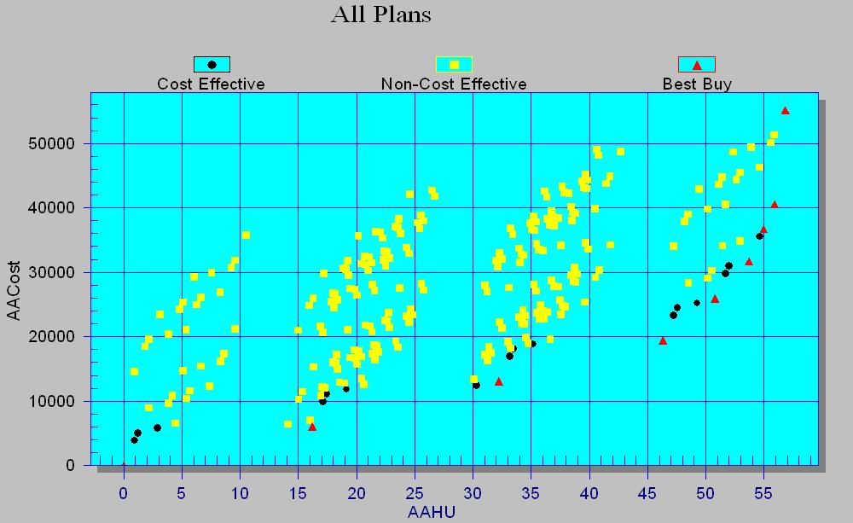

These analyses identified eight cost efficient and cost effective (“best-buy”) action alternatives. The following table displays these “best buy” alternatives, their construction costs, annualized costs, net AAHUs, and incremental cost per incremental benefit. Total project costs were annualized based on the FY 2007 project discount rate of 4.875% and a 50-year period of evaluation. The recommended plan is alternative 4 (shaded).

Alt. # | Alternative Name | Construction Cost | Incremental Cost (annualized) | Incremental Output (net AAHUs) | Incremental Cost Per Output
(no action) | A0B0C0D0E0F0G0H0 | $0.00 | $0 | 0.00 | $0.00
1 | A0B0C0D0E0F0G1H0 | $115,408.00 | $5,909 | 16.20 | $364.80
2 | A1B0C0D0E0F0G1H0 | $209,158.00 | $6,804 | 16.01 | $425.00
3 | A1B1C0D0E0F0G1H0 | $294,158.00 | $6,203 | 14.11 | $439.60
4 | A1B1C1D0E0F0G1H0 | $410,473.00 | $6,249 | 4.45 | $1,404.30
5 | A1B1C1D0E0F1G1H0 | $512,899.00 | $5,559 | 2.94 | $1,890.80
6 | A1B1C1D0E1F1G1H0 | $601,653.00 | $4,836 | 1.26 | $3,838.10
7 | A1B1C1D1E1F1G1H0 | $670,643.00 | $3,706 | 0.94 | $3,942.60
8 | A1B1C1D1E1F1G1H1 | $901,893.00 | $14,081 | 0.92 | $15,305.40

The following box graph displays all eight of these “best buy” alternatives. The recommended plan is represented by the dark red box (labeled “4”), for which an incremental gain of about 4.5 AAHUs is achieved with an additional cost of about $1,404 per AAHU.

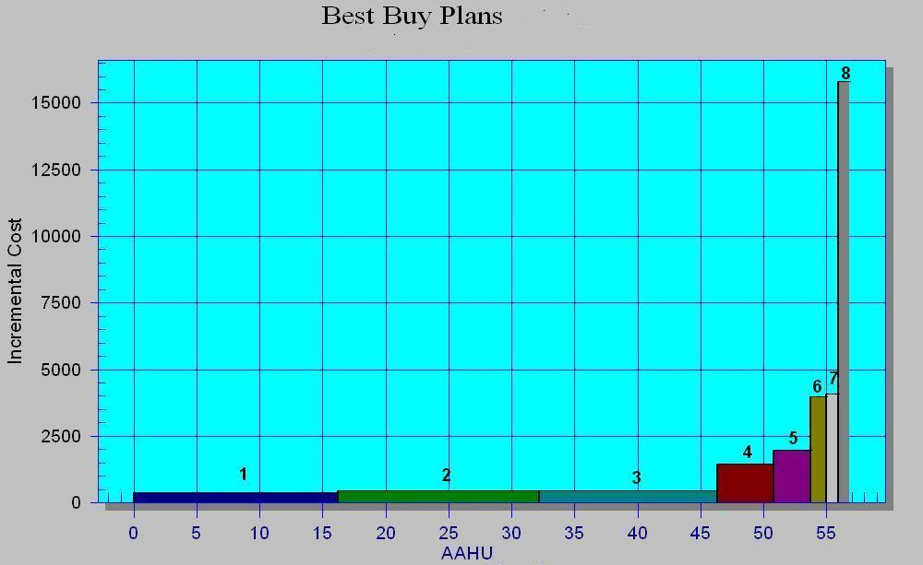

The recommended plan was selected from the list of eight “best buy” alternatives. In the box graph above, there are significant breakpoints that assist in identifying the recommended plan. Significant breakpoints occur between alternatives 1-2-3 and alternatives 4-5, between alternatives 4-5 and alternatives 6-7, and between alternatives 6-7 and alternative 8. Alternative1, Alternative 2, and Alternative 3 are considered to be wise investments because each of them provides a relatively large environmental benefit at a low cost (below $500 per AAHU). Alternative 6 and Alternative 7 were not chosen as the recommended plan because their additional increments (as compared to Alternative 4 and Alternative 5) were viewed by the interagency team to be of minimal benefit to the aquatic ecosystem (creation of deepwater habitat in an isolated slough on Westport Island with no natural connection to the river, creation of deepwater habitat in a small side channel on Dardenne Island near a main channel border dike field already with deep holes). Similarly, alternative 8 was rejected (bank stabilization at Howard Island and an unnamed island) because of the small benefit to be gained, as well as the high incremental cost per incremental gain (over $15,000 per AAHU), which exceeds the typical average for HREP projects ($3,000 to $4,000 per AAHU).

The interagency team believed that creation and maintenance of deepwater habitat in an island’s interior slough where that slough was naturally connected to the river would be beneficial to various riverine fishes, as in alternative 4. This alternative would restore optimal overwintering fisheries habitat to a type of aquatic habitat (isolated floodplain lake) where deep water is believed to be lacking in Pools 25 and 26. In the St. Louis District, creation and maintenance of deepwater habitat in an isolated floodplain lake has yet to be attempted, although deepwater habitat has been successfully created and maintained in main channel habitats using similar methods. For these reasons, alternative 4 was desirable, whereas alternative 5 was not. The additional increment of benefit provided by alternative 5 was not viewed by the team as valuable in terms of habitat gained (creation of deepwater habitat in abandoned cropland on Westport Island that would not be connected to the river).

Therefore, alternative 4 was chosen as the recommended plan. It includes measures A, B, C, and G. These include reforestation of hard-mast tree species in abandoned cropland on Westport and Dardenne Islands (measures A and B, respectively), restoring the natural connection between the river and the isolated slough on Bolter Island, along with creation of deepwater habitat in this slough, and construction of a rock dike structure adjacent to the deep area to maintain water depth (measure C), and restoring the natural connection between the river and the interior slough complex on Westport Island, along with installation of a water control structure (measure G).

The recommended plan has been formulated in consideration of the four criteria described in the Principles and Guidelines (U.S. Water Resources Council, 1983): completeness, efficiency, effectiveness, and acceptability. The plan is complete because it provides and accounts for all necessary investments or other actions to ensure the realization of the planning objectives, including future operation and maintenance activities by the U.S. Fish and Wildlife Service and the Missouri Department of Conservation. The plan is effective in that it contributes to the achievement of three of the four planning objectives (increase the spatial extent of the oak-hickory community in floodplain forests, restore and maintain connections between the river and adjacent backwater habitats, and create and maintain deepwater habitat in backwater areas). It is efficient because it is one of the eight most cost effective (“best-buy”) alternatives identified by the cost-effectiveness and incremental cost analyses. The recommended plan is acceptable because it is supported by the U.S. Fish and Wildlife Service and Missouri Department of Conservation, land managers of the project area’s islands, and it complies with all applicable laws, regulations and public policies.

(8) Study Methodologies.
Project outputs were generated for all action and the no-action alternatives using average annual habitat units as the unit of measurement. This particular unit of measurement is frequently used for Corps ecosystem restoration project planning, including the EMP-HREP program. Average annual habitat units were obtained by multiplying area of affected habitat (habitat quantity, expressed in acres) by habitat suitability (habitat quality, expressed as a habitat suitability index). Habitat suitability indices were generated by applying the Wildlife Habitat Appraisal Guide (WHAG) for terrestrial habitats and the Aquatic Habitat Appraisal Guide (AHAG) for aquatic habitats. These two methodologies are often used by the St. Louis District for EMP-HREP projects. The ecological models employed by the WHAG and AHAG characterize habitat suitability by assessing habitat conditions believed to be important to the well being of a range of animal species.

4. Views of Sponsor. The non-Federal sponsor for this project is the Missouri Department of Conservation (MDC). MDC has been in agreement with and supports the effort made to optimize the design leading to the recommended plan configuration. The sponsor has been a participant in all phases of the plan formulation process. MDC has expressed acceptance of the project in a “letter of intent” dated 23 June 2008.

5. Views of Federal, State, and Regional Agencies. As land manager of the project area’s islands, the Missouri Department of Conservation supports the recommended plan. The U.S. Fish and Wildlife Service expressed support for the project in its Final Fish and Wildlife Coordination Act Report by stating “The proposed project will be beneficial to the Mississippi River and biota dependent upon the river by improving habitat quality in this portion of river.” That agency requested that work in sloughs on Westport and Bolter Islands be restricted from occurring during the period from mid-March to early June to avoid impacts during the main fish spawning season.
The Osage Nation Tribal Historic Preservation Office stated that the proposal “will not adversely affect properties of cultural or sacred significance to the Osage Nation.” That office also requested that if during project construction any artifacts or human remains are discovered, work would immediately cease and the Office be contacted. A separate Summary of Public Involvement describes comments received during the public review process and District responses.

6. Environmental Compliance REQUIREMENTS. An Environmental Assessment (EA) was distributed to Federal, State, and regional agencies and the general public on 18 December 2007 as part of the public review process. The USFWS “concurred that with implementation of the conservation measures discussed in the [Section 404(b)(1) Evaluation] report, the project is not likely to adversely affect any known federally listed threatened or endangered species.” Section 401 water quality certification was issued by the Missouri Department of Natural Resources on 2 June 2008. The District’s 404(b)(1) Evaluation was signed on 25 June 2008. Authorization under Section 404 of the Clean Water Act and Section 10 of the Rivers and Harbors Act was granted by the St. Louis District on 25 June 2008. A Finding of No Significant Impact was signed for the project on 25 June 2008. The Missouri State Historic Preservation Office was included in the public review distribution of the Environmental Assessment and Public Notice, but did not respond in writing. The Osage Nation Tribal Historic Preservation Office expressed the opinion that the District complied with the National Historic Preservation Act by consulting with that office.

7. COSTS AND BENEFITS.
(1) Outputs. Benefits expected from the recommended plan (alternative #4, A1B1C1G1) are represented by a total of 50.77 average annual habitat units (AAHU). This total is the sum of 30.12 AAHU for terrestrial wildlife habitat gains and 20.65 AAHU for aquatic fisheries habitat improvements. The terrestrial benefits derive from reforestation of 110 acres of abandoned crop fields on Westport and Dardenne Islands with hard-mast tree species. The aquatic benefits accrue from improving fisheries habitat in the 73-acre interior slough complex on Westport Island and a 13-acre slough on Bolter Island, by making these habitats more accessible to riverine fishes and by improving water depth in the sloughs.

The WHAG assessment of tree planting shows that improvements in habitat quality for most evaluation species will be attained once the production of nuts and acorns begins, which would be in the first half of the 50-year project life. In qualitative terms, quality of the abandoned crop fields as forest habitat currently varies from poor to fair, and under future without conditions of natural succession, would vary from poor to good. With hard mast tree plantings, quality would improve over the future without condition slightly for six evaluation species, but would change from fair to good or good to excellent for the other four species (white-tailed deer, turkey, pileated woodpecker, fox squirrel), all of which include nuts and acorns in their diet.

The AHAG assessment forecasts gains in aquatic habitat suitability for all evaluation fish species. For most evaluation species, existing habitat quality is either fair or good, and under future without conditions it remains unchanged. With the project, the islands’ interior sloughs are expected to improve for all fish species, more so as spawning and rearing habitat than as overwintering habitat. This is because the existing sloughs are already rather shallow, and the creation of deepwater overwintering habitat is proposed at only one of the two affected islands.

(2) Costs. All project costs related to planning and construction are 100% Federal. The contract construction cost estimate for the recommended plan is $998,475.78, and it was prepared using MII software in April 2008. This cost estimate is displayed in TABLE 1 by feature at each island.

(3) Future OMRR&R Requirements. As the non-Federal sponsor, the Missouri Department of Conservation (MDC) would be responsible for all future operation, maintenance, and replacement of project features. No other entity would be involved in these activities. MDC would be responsible for all costs associated with these OMRR&R requirements. Total future OMRR&R costs of the recommended plan are estimated to be $5,859 each year over the 50-year project life; this figure is expressed in current dollars and is based on May 2008 price levels. These requirements include maintenance and replacement costs for reforestation at Westport and Dardenne Islands, operation, maintenance, and replacement costs for aquatic features at Westport Island, and maintenance and replacement costs for aquatic features at Bolter Island. Detailed OMRR&R costs appear in TABLE 2. The recommended plan includes an access road on Westport and Bolter Islands. A similar feature is not needed on Dardenne Island.

8. Schedule.
Study Process and Draft Report Preparation: January 2005 – November 2007
Public Review Process: December 2007 – February 2008
Final Report Preparation: May – June 2008
MVD Approval: July – August 2008
Plans and Specifications: October 2008 – September 2009
Contract Award: January 2010
Construction: April 2010 – November 2011

Implementation of “aquatic” work (excavation of the natural channels and deep hole, construction of the rock structure) is dependent on normal river stages. Dredging activities on Westport and Bolter Islands will be restricted from occurring during the period from mid-March to early June to avoid adverse impacts during the main fish spawning season. Planting of tree and shrub seedlings is preferable in the fall.

Removal of a few scattered large trees associated with channel excavation on Westport and Bolter Islands will be restricted to the colder months when maternity roosting of the Federally endangered Indiana bat (Myotis sodalis) is not known to occur (October 1 through March 31). With this restriction on construction, the recommended plan is unlikely to affect this bat. Therefore, removal of these few large trees could occur as early as April 2010 or as late as October-November 2010. With regard to the delisted bald eagle, the National Bald Eagle Management Guidelines will be applied if bald eagle use should change in the project area, to minimize potential project impacts that may constitute “disturbance” to this species.

9. Supplemental Information.
The recommended plan reflects geotechnical assumptions related to sediment removal from the natural channels on Bolter and Westport Islands. Based on an analysis of soil samples taken from these channels, deepening of these channels by up to five feet is not expected to result in the loss of channel water to any subsurface permeable layer, nor would water flowing through these channels (to the river or into the sloughs) be expected to cause erosion of the channel banks or bottom. Similarly, the proposed channels after mechanical excavation were designed relatively narrow and deep to promote sediment transport through the system, thereby reducing the amount of deposition in the channel. No maintenance of the channel on Bolter Island is expected, whereas periodic closure of the proposed water control structure in the channel on Westport Island is expected to result in some siltation, and the need for periodic sediment removal.

Post-construction monitoring and evaluation is proposed, and includes periodic tree seedling survival surveys, sedimentation surveys in the deep hole and dredged channels, water quality monitoring in these aquatic sites, and hydroacoustic fish sampling in the Bolter Island slough, over the 50-year project life. The approximate annual cost of this monitoring is $11,000. Monitoring will not be accomplished as part of the recommended plan, but as part of a separate program for pre- and post-project monitoring of all EMP-HREP projects in the St. Louis District.

10. FINANCIAL DATA. Economic and financial data for the recommended plan are displayed in TABLE 3.

11. FEDERAL ALLOCATIONS TO DATE.
Planning and Design Analysis: $ 754,000
Finalize Plans & Specifications: $ 77,000
Construction: $ 0

TABLE 1. Project Cost Estimate
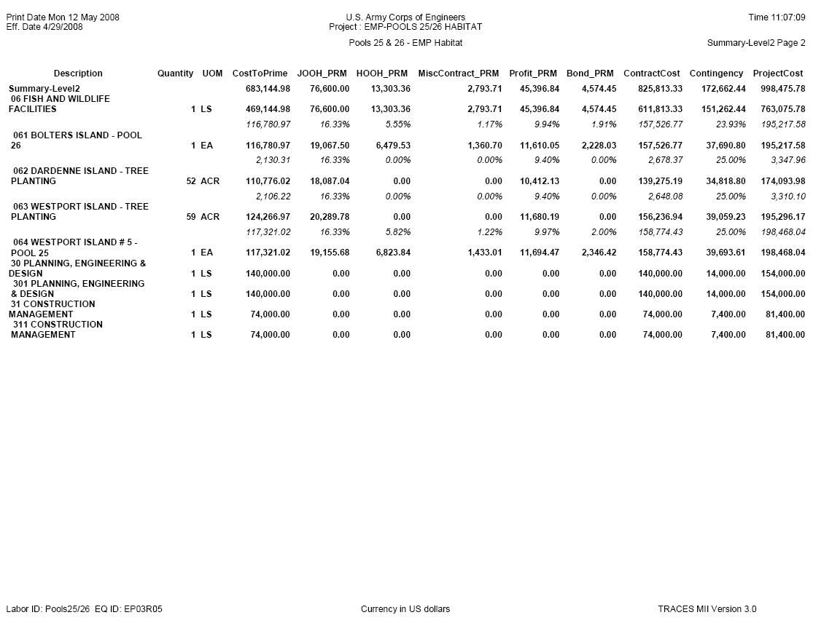
TABLE 2. Estimate of Future OMRR&R Requirements.

